SATURD
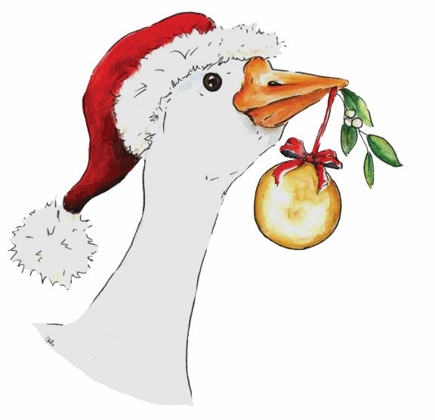
Chertsey Christmas Goose fair – Sat. December 4th 2021
Post: c/o 31, Grove Road, Chertsey, Surrey, KT16 9DN
Tel: 07790 604016
email: chertseygoosefair@gmail.com
web: www.chertseygoosefair.com

BUY A BAUBLE
NAME:
Contact number
Contact email

BAUBLE WORDS
(see numbers according to price)

Do you want to include picture or logo?

BAUBLE SIZE  (please tick) | SMALL BAUBLE -  4 WORDS or IMAGE | £25
 | MEDIUM BAUBLE  10 WORDS and IMAGE | £50
 | LARGE BAUBLE  15 words and company logo/image  -all large bauble buyers will be included in our sponsors lists and advertising | £100
CHEQUE/BACS PAYMENT.
Cheque payment: Please send cheque for CCGF (Chertsey Christmas Goose Fair) to the address above.
Bacs payment: Please use your ‘business name’ above as reference.
Account name: Chertsey Christmas goose fair Account number:33391280 sort code:20:42:76

FOR INTERNAL USE:

